LESSON 6: MOSFET
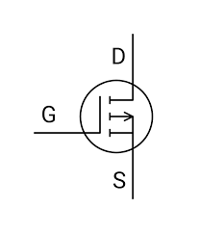

G – GATE
D – DRAIN
S – SOURCE

MOSFET STRUCTURE
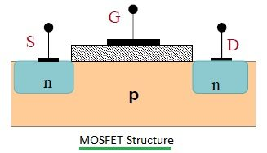

1 Substrate:
- Made of semiconductor material (commonly silicon).
- Can be either n-type or p-type, depending on the MOSFET type.
2 Source (S) and Drain (D):
- Source: The terminal through which carriers (electrons or holes) enter.
- Drain: The terminal through which carriers exit.
- Both are heavily doped regions (n+n^+n+ or p+p^+p+) to ensure good conductivity.
3 Channel:
- A thin region between the source and drain in the substrate.
- Conducts current when a voltage is applied to the gate.
4 Gate (G):
- A conductive electrode (metal or polysilicon) placed above the substrate.
- Controls the flow of current by modulating the channel.
5 Oxide Layer:
- A thin insulating layer (usually silicon dioxide) separates the gate from the channel.
- Prevents direct current flow between the gate and substrate, allowing field-effect control.
6 Body/Back Gate:
- The bulk of the substrate, often connected to a fixed potential (e.g., ground).

